**Installing the Android Development Environment**

<http://developer.motorola.com/docstools/library/Installing-Android-Dev-Environment/>

<http://www.dotblogs.com.tw/bowwowxx/archive/2010/08/25/17393.aspx>

Installation of the generic Android development environment (which uses Eclipse as an IDE) is a matter of:

* Downloading and installing the Android SDK.
* Downloading and installing Eclipse.
* Using Eclipse's Software Update mechanism to download and install the Android Development Tools (ADT).

Once you have installed all of the necessary software, you can verify your installation by creating a quick "Hello World"-style application and deploying it on an emulated Android handset.

**Verify That you Meet the System Requirements**

Before installing, you must verify that your development computer meets the system requirements.

1. Point your web browser to <http://developer.android.com/>. Click the SDK tab at the top of the page.
2. On the left side of the page, under "Current SDK Release", click System Requirements.
3. Ensure that your machine is running one of the listed operating systems, and that it has the proper JDK (Java™ Development Kit) as listed under "Eclipse IDE". If you need the JDK (the JRE alone is not sufficient; you need the full JDK), download the latest from <http://java.sun.com/javase/downloads/index.jsp> and install it. Download the 32-bit version even if you have a 64-bit computer and operating system.

**Download and Install the Android SDK**

1. Point your web browser to <http://developer.android.com/>. Click the SDK tab at the top of the page.
2. On the left side of the page, under "Current SDK Release", click Download.
3. Click the appropriate link to download the SDK for your host platform. Note that you will need to agree to the terms of the Android SDK License Agreement.
4. Unzip the downloaded file to a directory of your choosing on your development computer. Within the chosen directory, the zip file unpacks as a directory named for the platform, release, and build (for instance, android-sdk-mac_x86-1.5_r1).
5. So that you don't have to supply the full path to the Android tools directory[[1]](http://developer.motorola.com/docstools/library/Installing-Android-Dev-Environment/#1) when running tools from the command line, add it to your path:
   * On Microsoft® Windows®, right-click My Computer and select Properties. Select the Advanced tab and click Environment Variables. In the Environment Variables dialog, under System Variables, select Path and click Edit. Append the full path to the tools directory, separating it from the preceding path using a semicolon. Close all dialogs.
   * On Linux®, edit your ~/.bash_profile or ~/.bashrc file. If either sets the PATH environment variable, edit it so that it includes the full path to the tools directory. If neither file sets PATH, add the following line to either of the files:   
     export PATH=${PATH}:full_path_to_your_android_sdk_tools_dir

**Download and Install Eclipse**

1. Go to <http://www.eclipse.org/downloads/>. Find the entry labeled "Eclipse Classic" (as of this writing, version 3.4.2) and click the link on the right side appropriate for your platform.
2. From the page that appears, download the archive (.zip or .targ.gz depending upon your platform).
3. Extract the downloaded file to an appropriate location, such as C:\Program Files\ or /Applications/. Extraction creates a directory named eclipse within the chosen location.
4. If desired, create a shortcut that will simplify the launching of Eclipse:
   * On Windows, open the eclipse folder, right click eclipse.exe, select Send To, and then select Desktop (create shortcut).
5. Launch Eclipse. You will be asked to select a workspace:   
   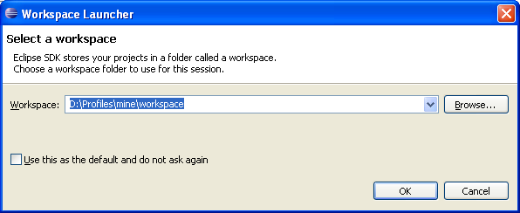
6. Specify a directory into which all of your Android projects should be stored. Note that you will probably want to create a new directory just for this purpose. If you do not want to be prompted for a workspace directory each time you launch Eclipse, select Use this as the default and do not ask again. Eclipse launches, and the Welcome view appears.
7. On the right side of the Welcome view, click the Go to the Workbench icon: 
8. You should now see the Eclipse workbench:

**Install the Android Development Tools (ADT)**

NoteNOTE: Eclipse uses its own proxy settings (and not those of your host computer) when accessing the Internet. If you access the Internet through a proxy server, you must configure Eclipse accordingly. Select Preferences from the Window menu (on Mac OS X, Preferences are located in the Eclipse menu). On the left side of the Preferences dialog, expand General and select Network Connections. Select Manual proxy configuration and fill in the fields as appropriate for your network setup. (Note that the Android Development Tools are installed using https; thus, you need to configure the SSL proxy.) Click OK when done.

1. From within Eclipse, select Software Updates from the Help menu. The Software Updates and Add-ons dialog appears.
2. At the top of the dialog, click Available Software.
3. On the right side of the dialog, click Add Site. The Add Site dialog appears.
4. Enter the following URL into the Location field and click OK:   
   <https://dl-ssl.google.com/android/eclipse/>
5. The URL you just added should now appear in the Available Software list. Click the checkbox to the left of it, and then click Install.  
   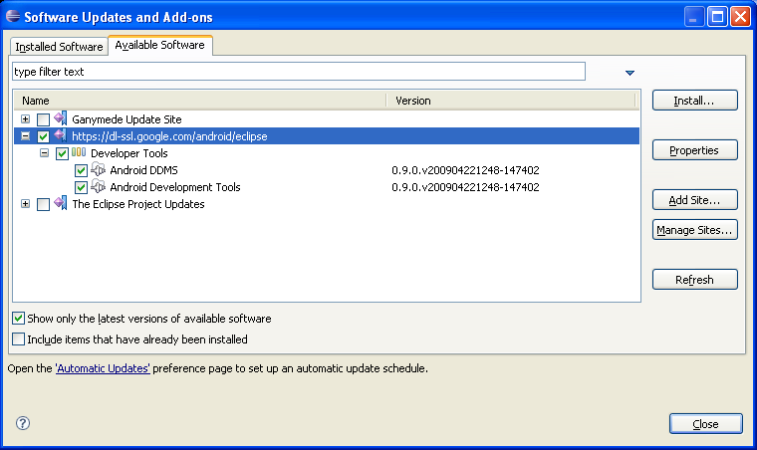
6. When the Install dialog appears, asking you to review and confirm the software being installed, click Next.
7. You are now asked to review and accept the licenses for the software being installed. If you accept them, select I accept the terms of the license agreements and then click Finish.  
   The Android Development Tools are downloaded and installed.
8. When installation is complete, you will be asked if you want to restart Eclipse. Click Yes and let it restart.   
   Once Eclipse has restarted, you have one last task to perform: you need to tell Eclipse where the Android SDK resides.
9. Open the Preferences dialog (on Windows or Linux, Window > Preferences).
10. On the left side of the Preferences dialog, click Android. A warning dialog appears, indicating that the location of the Android SDK has not been set up. Click OK to dismiss the warning.
11. In the SDK Location field, specify the directory that contains the Android SDK.
12. Click OK to register the SDK with Eclipse and close the Preferences dialog. 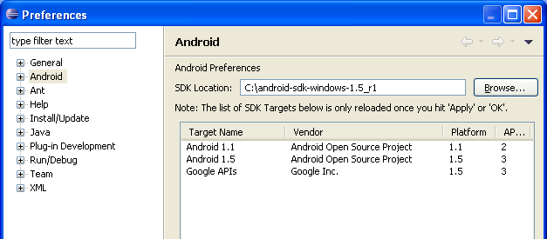

**Test Your Installation**

First, you must create at least one Android Virtual Device (AVD)[[2]](http://developer.motorola.com/docstools/library/Installing-Android-Dev-Environment/#2) to which you can deploy applications. Note that AVDs can be re-used; you need not create a new one each time you want to run an application.

1. Open a Command Prompt (a Terminal window).
2. Change to the Android SDK Tools directory. For instance:   
   cd \android-sdk-windows-1.5_r1\tools
3. Enter the following command to create an AVD named "android1_5":   
   android create avd -n android1_5 -t 3

The "-t 3" specifies that the target device runs Android 1.5 (API level 3) and supports the Google APIs; to create a target running Android 1.1, you would use "-t 1" instead.

Now, from within Eclipse, you can create and run an application:

1. Click File > New > Other. From the list of wizards, select Android > Android Project and click Next.   
   The New Android Project dialog appears.
2. Fill out the dialog as shown below (making sure to select Android 1.5 as the Build Target), and click Finish.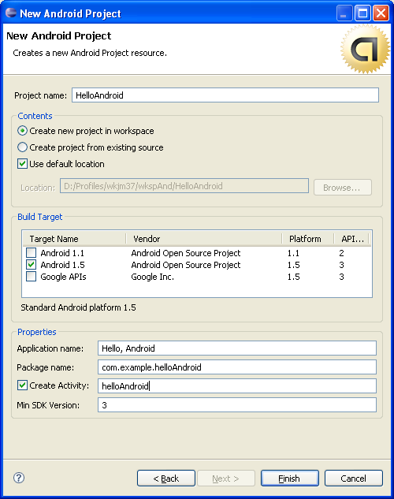

The project is created and added to the Package Explorer.

NoteNOTE: If you see errors in the Console view ("no classfiles specified") and the project name in the Package Explorer has a small red 'X' icon attached to it, right-click the project name in the Package Explorer and select Refresh.

1. Right-click HelloAndroid in the Package Explorer, and select Run As > Android Application.   
   The emulator launches in a separate window. Note that the emulator takes a few minutes to fully launch.   
   Watch Eclipse's Console view for an indication of how the launch is proceeding. In particular, when the "Uploading..." and "Installing..." messages appear, your application is being transferred to the emulated device. Then, the "Starting activity..." message indicates that your application is being launched.   
   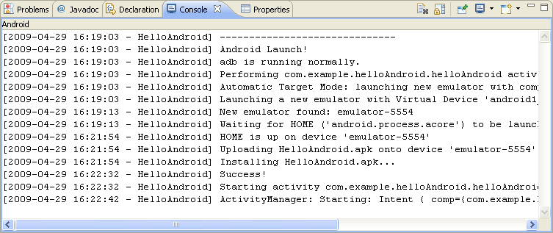

**Footnotes**

1. This is the directory named tools within the unpacked Android SDK directory. For instance, C:\android-sdk-windows-1.5_r1\tools.

2. Each AVD is a particular configuration of hardware options, system image, data storage, and an emulator "skin," all of which emulates an actual device. You can create multiple AVDs to enable testing on different emulated device types.

### 在Ubuntu建置Android開發環境（用套件管理程式安裝Eclipse）

### 安裝方式：（以下我在Ubuntu 12.04示範）

#### 1. 安裝Eclipse

開啟"Ubuntu軟體中心" → 在右上角的搜尋那邊輸入"**Eclipse**"，並按下"安裝"  
PS. 或是直接打開終端機輸入"sudo apt-get install eclipse”也可以安裝

[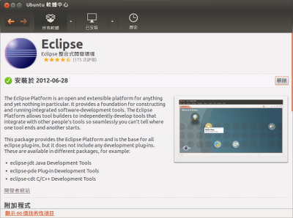](http://2.bp.blogspot.com/-1384p8kykBg/UD3FZPtFVbI/AAAAAAAACfg/Q7Yz3F8d8p4/s1600/Ubuntu+%E8%BB%9F%E9%AB%94%E4%B8%AD%E5%BF%83_020.png)

#### 2. 在Eclipse裡安裝Android SDK

如果是用第1點的方式用套件管理程式安裝Eclipse的話 請不要直接打開Eclipse這個軟體，不然會在"Install New Software"那邊卡住  
請打開終端機 → 輸入"sudo eclipse"（以root的帳號打開Eclipse這個軟體）

[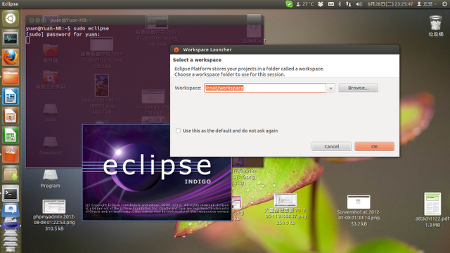](http://2.bp.blogspot.com/-kIjsnXKwbYA/UD3FKINhPGI/AAAAAAAACfY/NfPo-0L8UmQ/s1600/%E5%B7%A5%E4%BD%9C%E5%8D%80+1_021.png)

以root的權限打開Eclipse以後: 按下功能表上的"**Help**" → "**Install New Software...**"

[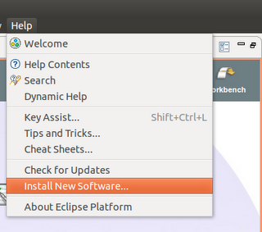](http://2.bp.blogspot.com/-vJRohe85vkI/UD3ErNqpl8I/AAAAAAAACfQ/FYGLTYRjZUk/s1600/%E6%93%B7%E5%8F%96%E9%81%B8%E5%8F%96%E5%8D%80%E5%9F%9F_022.png)

出現"Install"視窗後: 在"Work with"那邊輸入"https://dl-ssl.google.com/android/eclipse/ " → 把整個"**Developer Tools**"和"**NDK Plugins（選用）**"那地方勾起來後 → 再按下"Next" → 再次按下"Next" → 在這邊當然要選擇"I accept the terms of the license agreements"囉 → 接下來等待完成Android開發環境的安裝吧！！

[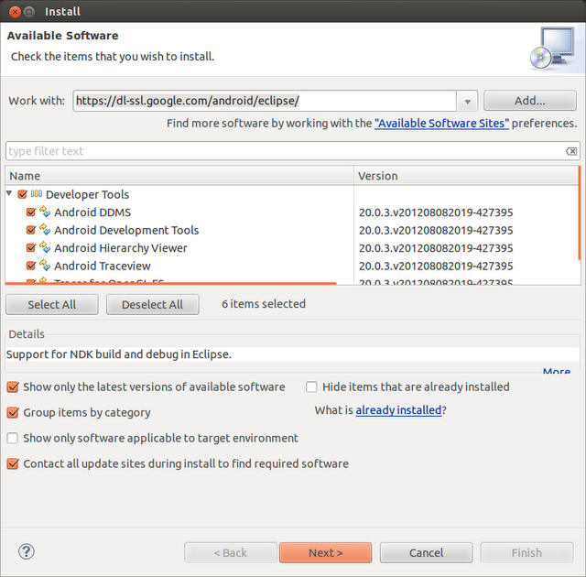](http://1.bp.blogspot.com/-XeNQ1bi704E/UD3GLv21ivI/AAAAAAAACfw/-IgX6noq1WE/s1600/Install+_023.png)

[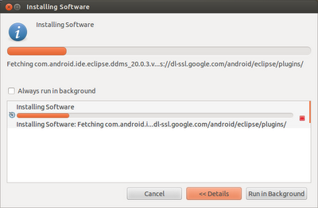](http://2.bp.blogspot.com/-8r_dWZY4Xf0/UD3G06L77xI/AAAAAAAACgI/gWvtvoUWsU0/s1600/Installing+Software+_026.png)

#### 3-1-1. Eclipse上設定Android SDK包對應

安裝完後按下"**Restart Now**”後，Eclipse會重新啟動，重新啟動後應該會出現"Welcome to Android Development"的視窗:

* 如果尚未下載Android SDK開發包的話: 這時候請選擇"**Install new SDK**"，也建議這兩個選項也一起勾選都安裝進去，至於"Target Location"那邊請自行選擇要把開發包安裝在哪裡 → 然後按下"Next"後等著下載安裝完成吧！！
* 已經下載Android SDK開發包的話: 這時候請選擇"**Use existing SDKs**" → 在"Existing Location"那邊選擇已經下載Android SDK並解壓縮後的資料夾路徑吧！！然後按下"Next"繼續完成安裝。

PS. 在Ubuntu裡，如果指定正確的路徑，卻出現無法抓到SDK資料夾，可能是資料夾沒有給root之外帳號的讀取權限

#### 3-2-1. 如果沒出現或錯過"Welcome to Android Development"視窗

如果已經下載Android SDK包的話，請直接跳到步驟3-2-2。如果沒下載，   
請到[Android SDK | Android Developers網站](http://developer.android.com/sdk/index.html)下載**Linux (i386)版的壓縮檔** → 下載完後請自行解壓縮到其中一個位置

#### 3-2-2. 讓Eclipse對應到Android SDK包

然後打開Eclipse → 按下功能表上的"Window" → 選擇"Preferences"

[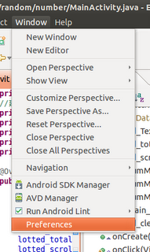](http://1.bp.blogspot.com/-bIMGfY5RHys/UD3MhUniStI/AAAAAAAACg0/1FIn6um11Sw/s1600/%E6%93%B7%E5%8F%96%E9%81%B8%E5%8F%96%E5%8D%80%E5%9F%9F_020.png)

出現視窗後: 點選左邊的"Anrdoid" → 在"SDK Location"那邊選擇剛剛解壓縮後的資料夾 → 然後按下"OK"就可以了！！

[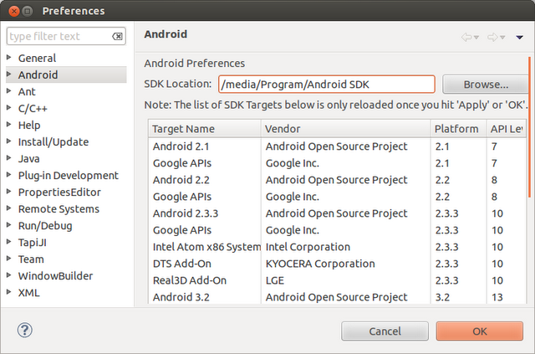](http://1.bp.blogspot.com/-Zqt5K30Bs5w/UD3MsMQdHAI/AAAAAAAACg8/0C18c4vNyN0/s1600/Preferences+_021.png)

#### 4. 將SDK裡的adb執行檔連結到/usr/bin/裡方便打終端機用（選用）

請打開終端機 → 輸入"sudo nautilus –no-desktop"（以root的帳號打開檔案總管）  
到"**你的Android SDK資料夾**/platform-tools/"裡的"**adb**"檔案上按右鍵 → "**建立連結**" → 然後把產生出來的連結檔案移動到"**/usr/bin/**"裡 → 重新命名為"**adb**"（要把"連結到 "字樣去除）

[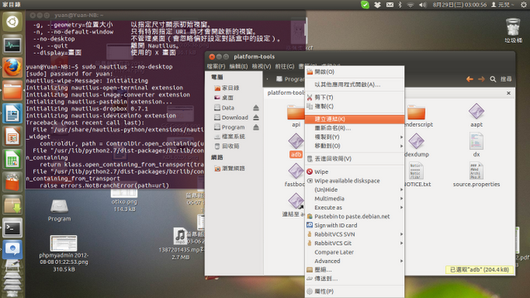](http://3.bp.blogspot.com/-1zNLpgUYEu0/UD3NmLLs7iI/AAAAAAAAChE/imG3V9en9io/s1600/%E5%B7%A5%E4%BD%9C%E5%8D%80+1_027.png)

弄好以後就可以在終端機試著輸入"**adb**"看看，如果有出現圖中的說明訊息，就表示成功了  
如果已經在手機開啟"**USB除錯中**"開啟並接上電腦的話，就可以下"**adb devices**"指令看看有沒有正確抓到，如果出現無法辨識的問題，請參考步驟6那邊...

**補充:** 如果下"**adb**"指令出現 "bash: **你的Android SDK資料夾**/platform-tools/adb: 沒有此一檔案或目錄" 錯誤訊息，請下"sudo apt-get install lib32ncurses5 lib32stdc++6"指令先把需要的套件安裝好後再下adb看看吧！！  
PS. 其實整個步驟4不做也沒關係，還是可以照常使用，主要是為了日後下adb指令會比較方便。如果不做此步驟的話，日後要使用adb指令的話，請打開終端機 → 先輸入"cd **你的Android SDK資料夾**/platform-tools/" → 然後再下"./adb 你要的參數" （只是每次要下adb前得先做cd改變路徑那樣）

#### 5. 下載安裝你要開發的Android版本

請在Eclipse工具列上按下"**Opens the Android SDK Manager**"的按鈕  
（或是直接打開" **你的Android SDK資料夾**/tools/android "也可以）

[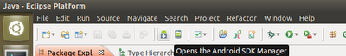](http://2.bp.blogspot.com/-stZJWUzc43A/UD3TTM7VTwI/AAAAAAAAChY/ExE5Aa3ut-U/s1600/%E6%93%B7%E5%8F%96%E9%81%B8%E5%8F%96%E5%8D%80%E5%9F%9F_022tool.png)

在"Android SDK Manager"視窗上就勾選你要開發哪一版Android吧！！（建議是包含舊一點的版本比較方便開發出舊一點的Android也能支援的） → 然後按下"**Install Packages...**" → 然後選擇"**Accept All**"後按下"**Install**"開始安裝！！

另外如果你有實體Android手機平板的話，可以直接在手機上測試喔。

* Android 4.0以上: 進入"設定"→"開發人員選項"→把"**USB除錯中**"選項勾起來
* 其他Android版本: 進入"設定"→"應用程式"→"開發"→把"**USB除錯中**"選項勾起來

[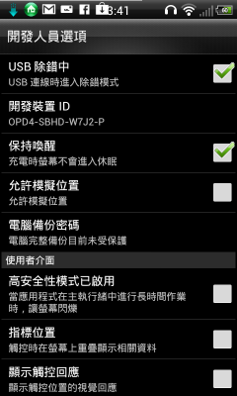](http://3.bp.blogspot.com/-juhvAT4DmUM/UD3gVqcPenI/AAAAAAAAChs/fs_5oEFL4tY/s1600/2012-08-29_03-41-12.png)

然後用USB連接線接上電腦後就可以測試了！！  
如果沒有Android手機or平板的人，請在Eclipse工具列上按下"Opens the Android Virtual Device Manager" → 建立一台Android模擬器之後就能測試囉！！  
建立好專案後就可以直接把手機接上(或是開模擬器)，然後按下工具列上的"Run"就會把專案丟到Android裝置測試囉！！

|  |
| --- |
| [http://2.bp.blogspot.com/-3OsEE4XLFpc/UD3hS1DxYyI/AAAAAAAACh0/nqpMnZq8PYM/s640/Android+Device+Chooser+_032.png](http://2.bp.blogspot.com/-3OsEE4XLFpc/UD3hS1DxYyI/AAAAAAAACh0/nqpMnZq8PYM/s1600/Android+Device+Chooser+_032.png) |
|  |

<http://www.dotblogs.com.tw/bowwowxx/archive/2010/08/25/17393.aspx>

一般Android手機在windows上，灌一下原廠網站的drive就可以讓pc連接到手機了，但Ubuntu並沒有driver吶

一直使用SDK裡面的模擬器也不是辦法，安迪兒今天介紹是在Ubuntu下連接Android手機，設定的過程如下

一、接上電腦和手機的usb線(記得手機的debug選項要勾起)

在Ubuntu的終端機下打

lsusb

這邊可以看到安迪兒的手機是Bus002那個 Acer Inc(每個人的手機不同)

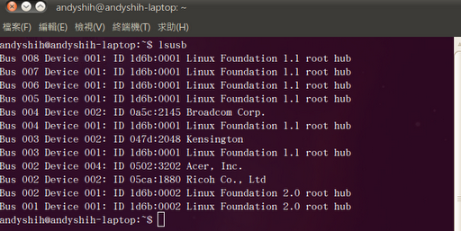

二、建立rules文件(其實Ununtu是捉的到USB的我們只要再幫他建一個rules讓他知道就好了)

根據Google的 [Android Developing on a Device](http://developer.android.com/guide/developing/device.html)，記得要看一下，裡面有各廠牌手機的代碼，和建rules的內容

a.開[root權限的檔案總管](http://www.dotblogs.com.tw/bowwowxx/archive/2010/06/08/15735.aspx)在etc/udev/rules.d/ 建一個50-android.rules的檔

建新檔案的指令

cd /etc/udev/rules.d  
sudo gedit 50-android.rules

b.填入rules內容

SUBSYSTEM=="usb",SYSFS{"Acer, Inc."}=="0502", MODE="0666"

這邊視每隻手機的不同而內容不同

"Acer, Inc."->換成lsusb指令show出的字眼

"0502"->查一下[Android Developing on a Device](http://developer.android.com/guide/developing/device.html)廠牌的USB Vendor ID

MODE="0666"->固定的不用理會

改完內容後，存檔

記得設一下檔案權限a+r

chmod a+r /etc/udev/rules.d/50-android.rules

再重啟一下udev目錄下的東西

sudo /etc/init.d/udev restart

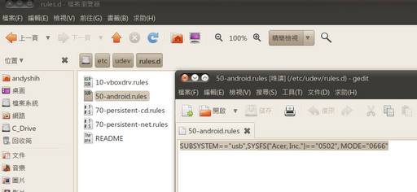

三、設定完rules檔後在 android sdk 的 tools 目錄下運行adb(Android Debug Bridge)吧

進到捉回來的Android sdk tools目錄下

先kill server再啟一次, 順利的話會出現successfully

sudo ./adb kill-server  
sudo ./adb devices

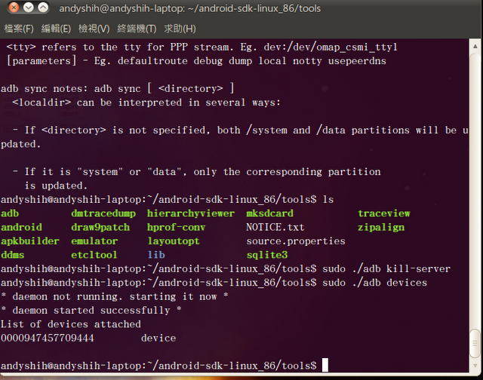

這個時候adb就運行起來嘍，就可以讓Eclipse或是google sdk 連接手機使用了